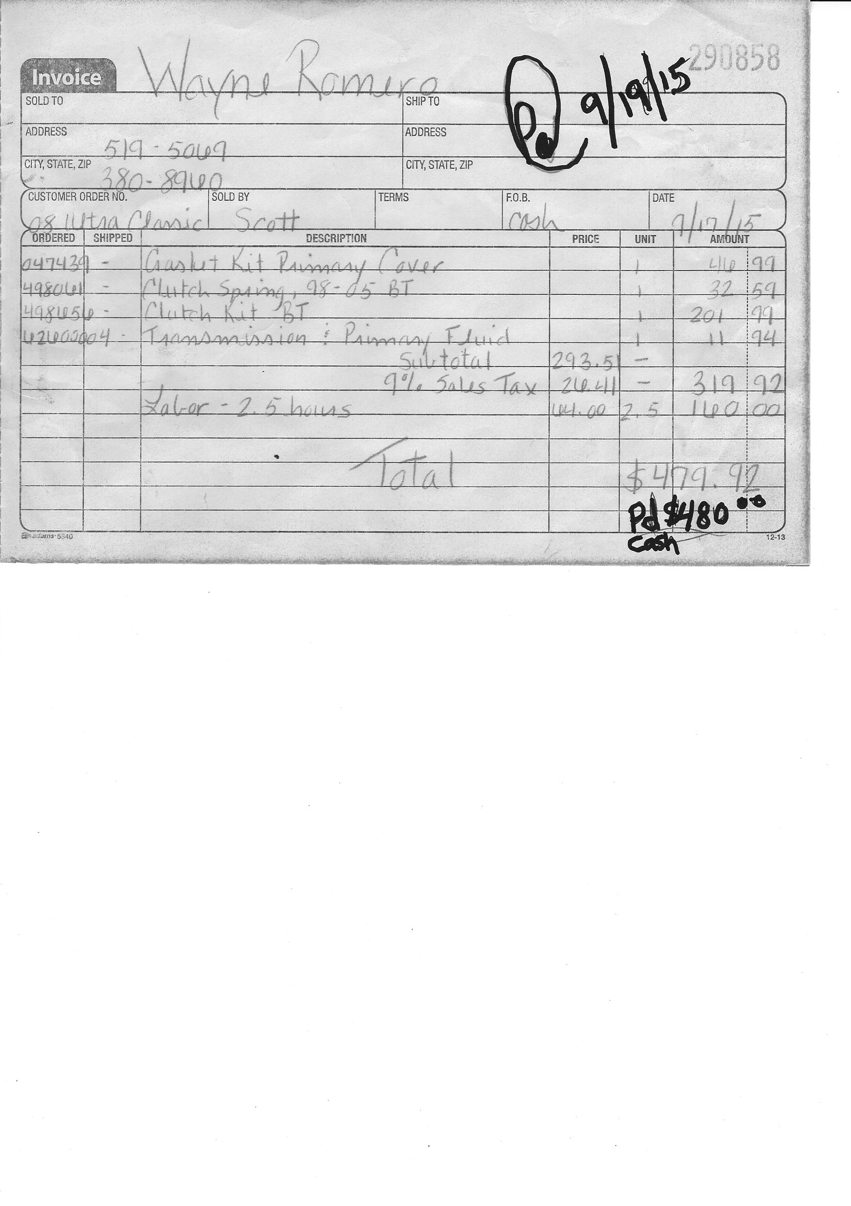
←Invoice Number

←Retail Price

←Subtotal Amount
←Sales Tax
[Type a quote from the document or the summary of an interesting point. You can position the text box anywhere in the document. Use the Text Box Tools tab to change the formatting of the pull quote text box.]
←Labor Total

←Invoice Total

- Use an Invoice with an actual Invoice Number for tracking.
Example: Put this number in the PO (Purchase Order) column when ordering the parts through Tucker Rocky
- Fill out as much information as possible (Name, Phone #, Motorcycle Year and model, etc.)
- Enter Part Description with the part number
- Enter Part Amount. This is the Retail Price or discounted price. Not our cost!!
The retail price is the price in the catalog. Nobody sees our dealer pricing!
- Add all the parts up for a Subtotal Amount
- Multiply the Subtotal Amount X .09 (9%) for Sales Tax
Example: $293.51 (Subtotal Amount) x .09 (9%) = $26.41 (Sales Tax)
- Add Labor Total. This includes both Repair Work and Dyno Tune. This does not have sales tax.
- Add Subtotal Amount + Sales Tax + Labor Total to get the Invoice Total
- When the Invoice is paid, Write on the invoice, the date, amount received, and cash or check
This Invoice is now complete. If there is a balance owed on that invoice, Do not make a new invoice showing a previous balance owed. If a payment is made, a receipt can be given to show it was applied to that Invoice Number. Each invoice number must be paid off or it will show as un-paid in accounting software.

